$65,000.00
QUENZER-PETERSON
1210 NORTH MAIN ST. MOBRIDGE
MOBRIDGE THOMPSON’S OULOTS LOT 8C EXC N 10’ & N ½ LOT 8D
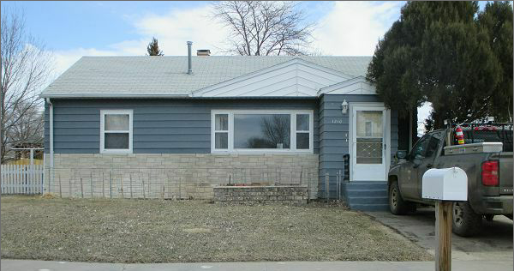
RECORD # 6469

LOT SIZE 75’ X 97’ GROUND FLOOR AREA 912 SQ FT
SINGLE FAMILY-ONE STORY 2 BEDROOMS ABOVE 1 BELOW
AVERAGE QUALITY-CONDITION 1 BATH ABOVE- ¾ BATH BELOW
BUILT IN 1951 BASEMENT 912 SQ FT 456 FIN REC
GAS HEATED-CENTRAL AIR DETACHED GARAGE 288 SQ FT
SOLD ON 1/23/18 FOR $65,000 SOLID WALL PORCH 28 SQ FT
ASSESSED IN 2017 AT $54,240 WOOD DECK SLIDING GLASS DOOR
ASSESSED IN 2012 AT $33,285
RECORD # 6469

