$300,000.00
BERG-JENSEN
1418 KENNEDY DR, MOBRIDGE
MOBRIDGE SHOR ACRES LOT 120
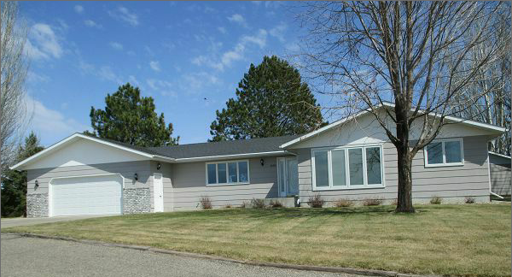
RECORD # 6431

LOT SIZE 122’ X 145’ GROUND FLOOR 1742 SQ FT
SINGLE FAMILY, ONE STORY 4 BEDROOMS 2 FULL BATHS
AVERAGE QUALITY AND CONDITION ½ BATH AND ¾ BATH
NATURAL GAS CENTRAL AIR BASEMENT 1742 SQ FT
2014 SHINGLES GOOD FINISHED LIVING 1000 SQ FT
WINDOW WELLS LARGE ENOUGH FOR EGRESS WOOD DECK 278 SQ FT
2001 12’ X 18’ ADDN TO GARAGE $3,000 OPEN SLAB 64 SQ FT
1998 18’ X 22’ GARAGE $5,000 ATTACHED GARAGE 884 SQ FT
SOLD ON 2/13/17 FOR $300,000 BOOK 17 PAGE 86 DETACHED 18’ X 39’
ASSESSED IN 2016 AT $265,550 IN 2012 AT $212,665 EGRESS WINDOW
RECORD # 6431
SOLD IN 2001 FOR $145,000 BOOK 01 PAGE 380

