$371,000.00
VOGEL-BERG
1506 KENNEDY DRIVE, MOBRIDGE
MOBRIDGE SHOR ACRES LOTS 78,79,80 & 81 & S 112’ OF LOT 82
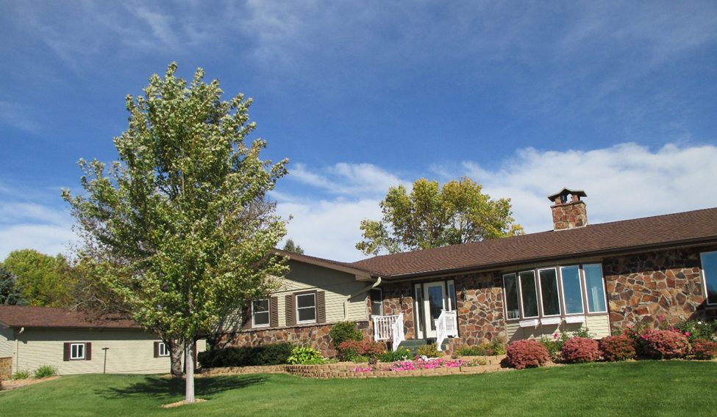
RECORD # 6404

LOT SIZE 257’ X 123’ GROUND FLOOR 2244 SQ FT
SINGLE FAMILY BASEMENT 2244 SQ FT
ONE STORY 1122 SQ FT FINISHED LIVING
AVERAGE QUALITY AND CONDITION 4 BEDROOMS 3 ½ BATHS
BUILT IN 1972 11 FIXTURES
2 UNITS CENTRAL AIR NATURAL GAS 2 NATURAL GAS FIREPLACES
LARGE STAMPED CONCRETE DRIVE, ROCK FACE UNDERGROUND APRINKLER
3 SEASON PORCH, DECK SLIDING GLASS DOORS DETACHED GARAGE 1344 S F
2011-NEW 28 X 48 SHOP $40,000 ATTACHED GARAGE 950 SQ FT
SOLD ON 8/29/16 FOR $371,000 BOOK 16 PAGE 672 HOT TUB AND SAUNA
ASSESSED IN 2016 AT $289,270, IN 2012 AT $178,290

RECORD #6404

