$260,000.00
NELSON-PLATINUM PC LLC
1711 WEST HWY 12, MOBRIDGE
MOBRIDGE SHOR ACRES S. 100’ OF N. 350’ OF LOT B
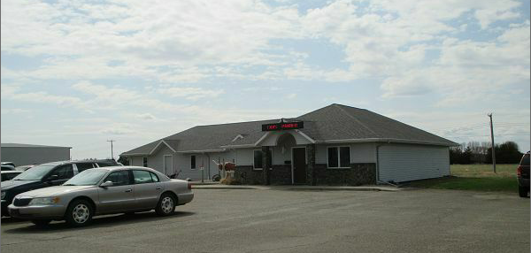
RECORD #6386

LOT SIZE 100’ X 230’
100% OFFICE
ONE STORY
BUILT IN 1993
WARMED AND COOLED AIR
TOTAL AREA 2,892 SQ FT
2001 ADDITION TO BUILDING $50,000
NEW DOOR $200
AVERAGE CONDITION AND QUALITY
PARKING LOT
SOLD ON 2/23/17 FOR $260,000
ASSESSED IN 2016 AT $220,000
SOLD IN 2013 FOR $220,000
ASSESSED IN 2012 AT $231,335

