$27,900.00
TB PROPERTIES-MARSHALL
308 2ND AVE WEST, MOBRIDGE
MOBRIDGE ORIGINAL N ½ OF LOT 8 (AKA LOT8B) BLOCK 4
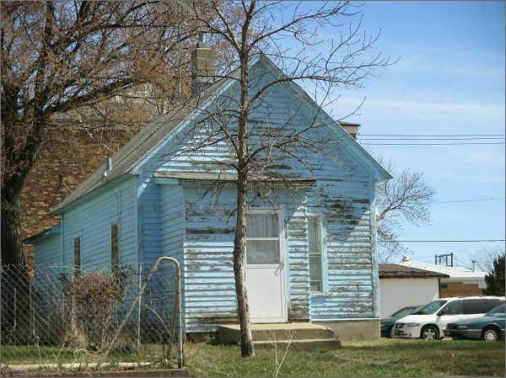
RECORD #6256

LOT SIZE 25’ X 140’ TOTAL LIVING AREA 576 SQ FT
SINGLE FAMILY 1 BEDROOM 1 BATH
ONE STORY BASEMENT 576 SQ FT
AVERAGE QUALITY AND CONDITION WALL PORCH 35 SQ FT
BUILT IN 1922+ - OPEN SLAB PORCH 156 SQ FT
NATURAL GAS WINDOW AIR
2015 LAP SIDING POOR, ALUMINUM/WOOD POOR RECORD #6256
SOLD ON 10/07/16 FOR $27,900 BOOK 16 PAGE 851
ASSESSED IN 2017 AT $8,870 SOLD IN 2014 FOR $6,500

