$72,000.00
PIATT-STICKNEY
914 8TH ST WEST, MOBRIDGE
MOPBRIDGE NWTS CO’S 3RD ADDN E ½ LOTS 7 & 8 BLOCK 32
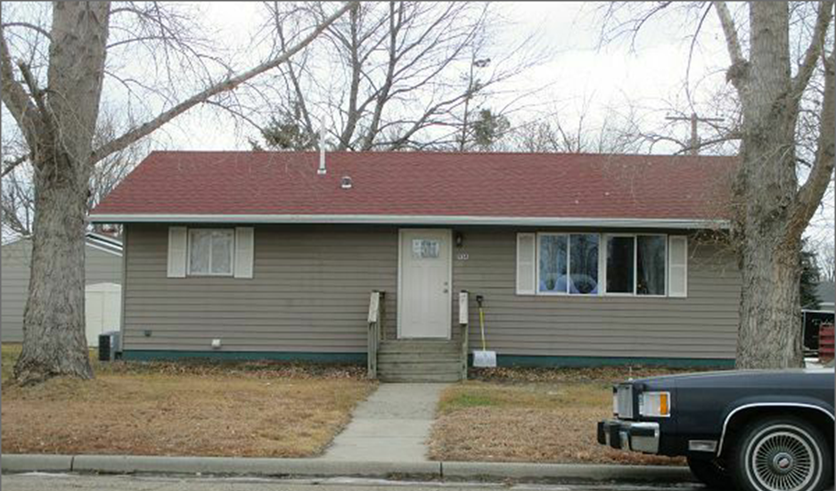
RECORD #6155

LOT SIZE 60’ X 100’ TOTAL LIVING AREA 960 SQ FT
SINGLE FAMILY ONE STORY BASEMENT 960 SQ FT
AVERAGE QUALITY & CONDITION 2 BEDROOMS
BUILT IN 1955 1 ½ BATHS
2015 FULL REMODEL, WINDOWS, WALLS
CABINETS, VINYL SIDING, BATHROOMS
NATURAL GAS, FLOORING DRY WALL
SOLD ON 11/21/17 FOR $72,000
ASSESSED IN 2017 AT $43,020 RECORD #6155
SOLD IN 2012 FOR $23,000
ASSESSED IN 2012 AT 32,780

