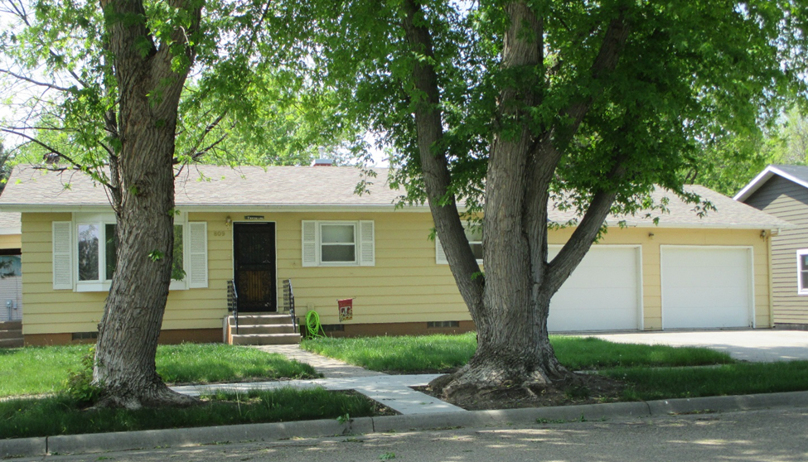
$110,000.00
BRIDGE CITY PROPERTIES-STEEN
809 8TH AVE WEST
MOBRIDGE NWTS CO’S 3RD ADDN LOT 5 & 25’ OF LOT 4 BLOCK 32
RECORD #6153

LOT SIZE 75’ X 120’ GROUND FLOOR 886 SQ FT
SINGLE FAMILY 2 BEDROOMS
ONE STORY 1 BATHROOM 7 FIXTURES
AVERAGE QUALITY AND CONDITION BASEMENT 886 SQ FT
BUILT IN 1968 BASEMENT 443 SQ FT FINISHED
CENTRAL AIR NATURAL GAS ATTACHED DOUBLE GARAGE 624 SQ FT
2014 SHINGLES GOOD DETACHED GARAGE 576 SQ FT
SOLD ON 11/03/2015 FOR $100,000 BOOK 15 PAGE 842 UTILITY SHED 10’ X 12’
ASSESSED IN 2016 AT $105,210
ASSESSED IN 2013 AT $72,080
SOLD ON 11/15/16 FIR $110,000 BOOK 16 PAGE 833
RECORD #6153

