$125,000.00
FOX-GRETHE
901 9TH AVE WEST, MOBRIDGE
MOBRIDGE NWTS CO’S 3RD ADDN S 95’ OF LOTS 3 & 4
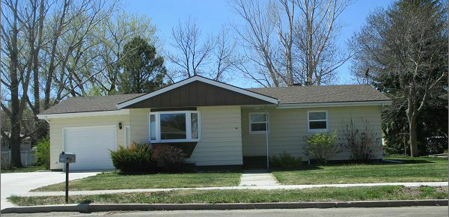
RECORD #6137

LOT SIZE 95’ X 120’ GROUND FLOOR 1040 SQ FT
SINGLE FAMILY ONE STORY 2 BEDROOMS 1 BATH 5 FIX.
AVERAGE QUALITY AND CONDITION BASEMENT 1040 SQ FT
BUILT IN 1968 ATTACHED GARAGE 384 SQ FT
CENTRAL AIR NATURAL GAS 1987 SPRINKLER SYSTEM
2014; SHINGLES GOOD,BOW WINDOW EAST 1987 FENCE
METAL SIDING, WOOD UTILITY POOR 1984 STEEL SIDING
PAVED PATIO WEST, 2012; BATHROOM REPAIRS
SOLD ON 4/4/17 FOR $125,000
ASSESSED IN 2016 AT $117,850
SOLD IN 2011 FOR $69,320
SOLD IN 2012 AT $63,075 RECORD #6137

