$75,000.00
SALVERSON-JENSEN
1009 8TH AVE WEST, MOBRIDGE
MOBRIDGE NWTS CO’S 3RD ADDN S ½ OF LOT 2 & ALL OF LOT 3 BLOCK 28
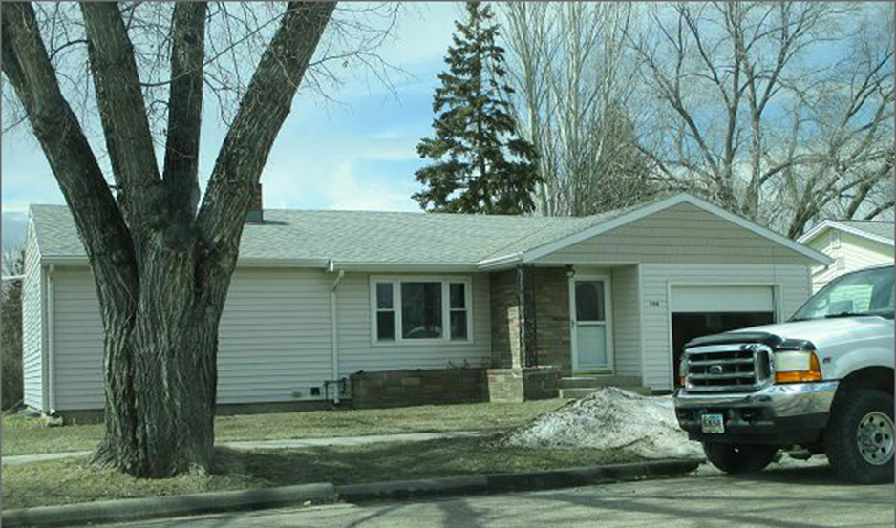
RECORD #6121

LOT SIZE 75’ X 120’ GROUND FLOOR 1262 SQ FT
ONE STORY-SINGLE FAMILY 3 BEDROOMS 2 ½ BATHS
AVERAGE QUALITY & CONDITION BASEMENT 1262 SQ FT
BUILT IN 1945 947 SQ FT FINISHED REC.
2014; ROOF GOOD, FOUNDATION GOOD ATTACHED GARAGE 274 SQ FT
CENTRAL AIR, NATURAL GAS WOOD UTILITY SHED
SOLD ON 2/21/18 FOR $75,000
ASSESSED IN 2017 AT $92,440
ASSESSED IN 2012 AT $57,385 RECORD #6121

