$77,000.00
LARSON-HULM
1103 3RD AVE WEST, MOBRIDGE
MOBRIDGE NWTS 2ND ADDITION LOT 8 BLOCK 17
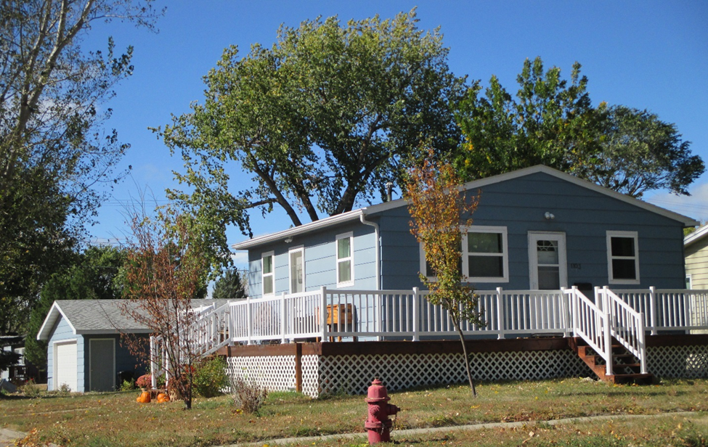
RECORD #6027

LOT SIZE 46’ X 140’ GROUND FLOOR LIVING 576 SQ FT
SINGLE FAMILY FINISHED BASEMENT 576 SQ FT
ONE STORY 1 BEDROOM GROUND 3 BSMT
AVERAGE AGE AND CONDITION 1 BATH 7 FIXTURES
CENTRAL AIR NATURAL GAS BUILT IN 1962
2007 24’ X 30’ GARAGE DETACHED
2014 WOOD DECK 280 SQ FT
MASONITE SIDING GOOD
SOLD ON 1/18/18 FOR $77,000 BOOK 18 PAGE 49 RECORD #6027
ASSESSED IN 2016 AT $69,000; IN 2012 AT $21,050
SOLD IN 2016 FOR $72,000 BOOK 16 PAGE 738
SOLD IN 2010 FOR $35,000, IN 2007 FOR $16,000

