$65,000.00
KUMBAYA LLC- PESKEY
805 3RD AVE WEST, MOBRIDGE
MOBRIDGE NWTS 1ST ADDN LOT 6 BLOCK 12
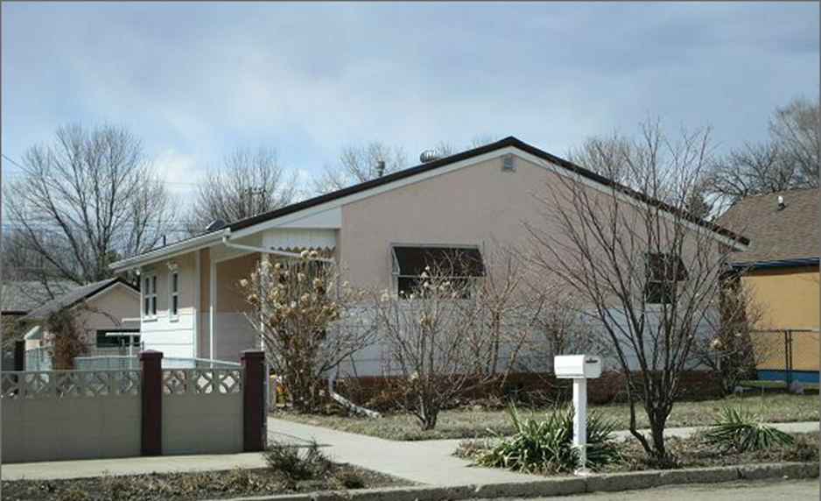
RECORD #5979

LOT SIZE 40’ X 140’ GROUND FLOOR 893 SQ FT
ONE STORY-SINGLE FAMILY 2 BEDROOMS GROUND FLOOR
AVERAGE QUALITY & CONDITION 2 FULL BATHS, ONE ½ BATH
BUILT IN 1960 BASEMENT 893 SQ FT
2014; METAL ROOF ON HOUSE & GARAGE 535 SQ FT FINISHED BASEMENT
CENTRAL AIR-NATURAL GAS 1 BEDROOM BASEMENT
SOLD ON 1/5/18 FOR $65,000 DETACHED GARAGE 472 SQ FT
ASSESSED IN 2017 AT $71,130 ROOFED PORCH 64 SQ FT
SOLD IN 2012 FOR $50,000 KNEE WALLED PORCH 100 SQ FT
ASSESSES IN 2012 AT $39,265

RECORD #5979

