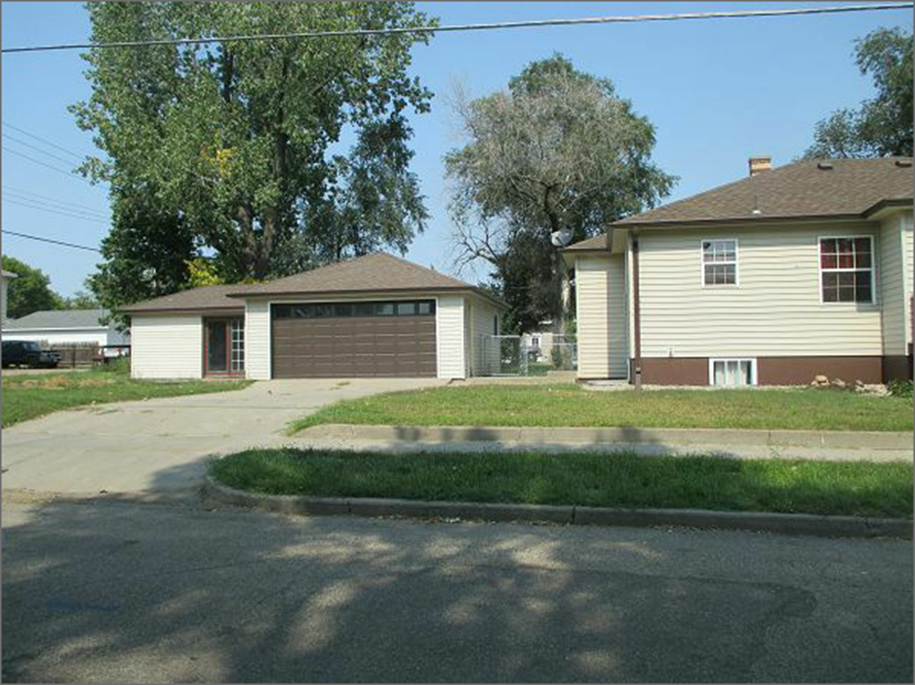
$140,000.00
GROSZ- KNUTH
302 8TH ST WEST

GARAGE
RECORD #5970

