$20,000.00
HEPPER-QUENZER
913 6TH AVE WEST, MOBRIDGE
MOBRIDGE NWTS 1ST ADDITION LOTS 4 & 5 BLOCK 6
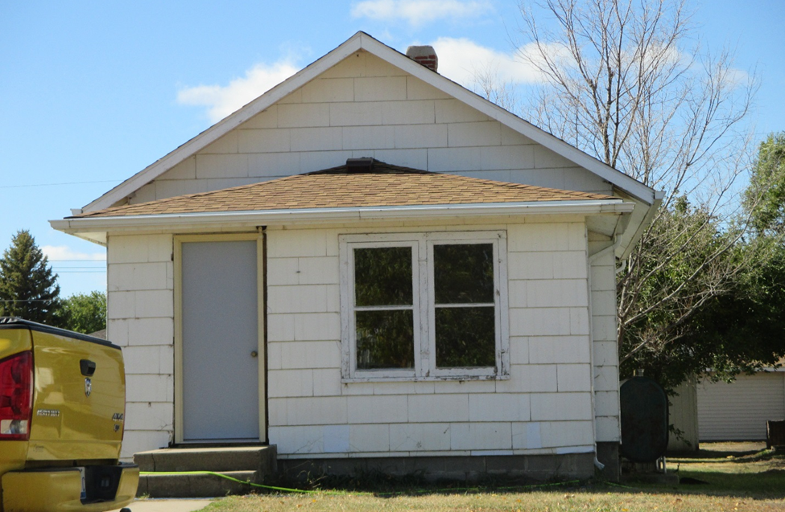
RECORD #5938

LOT SIZE 91 X 140 GROUND FLOOR 558 SQ FT
SINGLE FAMILY BASEMENT 558 SQ FT
ONE STORY 1 BEDROOM 1 BATH 5 FIXTURES
AVERAGE QUALITY AND CONDITION DETACHED GARAGE 558 SQ FT
CENTRAL AIR FUEL OIL SOLID WALL PORCH 236 SQ FT
2014-ROOF POOR,EASEMENT WINDOWS-TRIM POOR
BLOCK FOUNDATION/POURED FOUNDATION
SLATE SIDING-FAIR, SHED-POOR
SOLD ON 9/27/16 FOR $20,000 BOOK 16 PAGE 730 RECORD #5938
ASSESSED IN 2016 AT $29,850; IN 2012 AT $21,040
SOLD ON 8/23/16 FOR $15,000 BOOK 16 PAGE 657
SOLD IN 2008 FOR $15,000 BOOK 08 PAGE 438

