$149,000.00
GROSKOPF- FRYLING
1005 4TH AVE WEST
MOBRIDGE NWTS 1ST ADDN S 42.5’ OF LOT 4 & N 17.5’ OF LOT 5 BLOCK 3
RECORD #5922

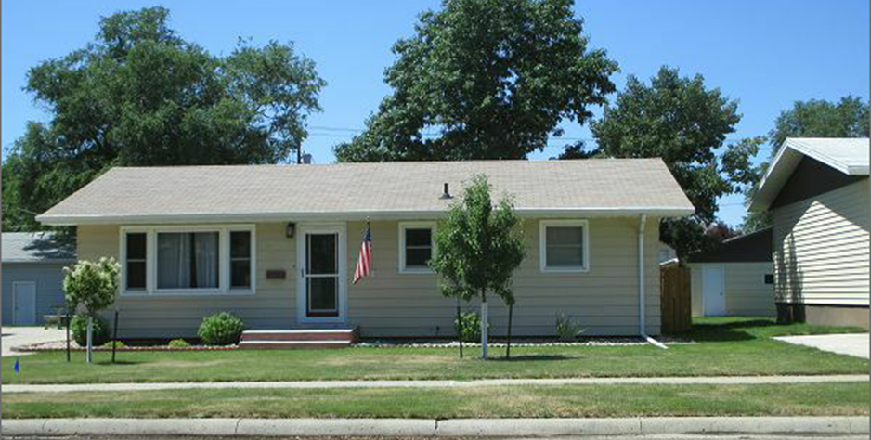
LOT SIZE 60’ X 140’ GROUND FLOOR 1025 SQ FT
SINGLE FAMILY 4 BEDROOMS 2 UP, 2 DOWN
ONE STORY 2 ½ BATHS
AVERAGE QUALITY AND CONDITION BASEMENT 1025 SQ FT
BUILT IN 1965 + - 500 SQ FT FIN. REC.
CENTRAL AIR NATURAL GAS DETACHED GARAGE 864 SQ FT
2014; ROOF SHINGLE FAIR, SUNKEN WINDOWS WOOD DECK 196 SQ FT
2001 INSTALLED SPRINKLER SYSTEM 10 X 11 SHED
SOLD ON 6/2/17 FOR $149,000
ASSESSED IN 2017 AT $120,120, IN 2012 AT $78,380
SOLD IN 2012 FOR $125,000 RECORD # 5922

