$137,900.00
WAHL-RICHARDS
1010 3RD AVE WEST, MOBRIDGE
MOBRIDGE NWTS 1ST ADDN N ½ OF LOT 13 & ALL OF LOT 14 BLOCK 1
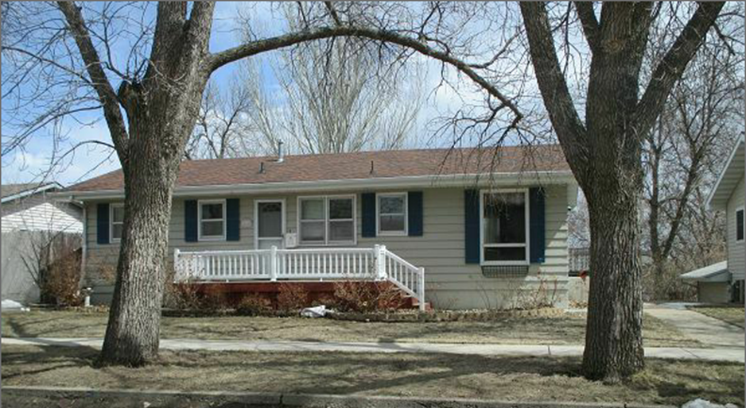
RECORD #5910

LOT SIZE 60’ X 140’ GROUND FLOOR 1092 SQ FT
SINGLE FAMILY-ONE STORY 4 BEDROOMS, 1 FULL BATH
AVERAGE QUALITY & CONDITION 1 THREE QUARTER BATH
BUILT IN 1965 1 HALF BATH
2014; ROOF GOOD, WINDOWS GOOD BASEMENT 780 SQ FT
POURED BSMT, SIDING FAIR WALKOUT WITH FULL LIVING
SOLD ON 2/5/18 FOR $137,900 ATTACHED GARAGE 12’ X 26’
ASSESSED IN 2017 AT $134,610 DETACHED GARAGE 28’ X 28’
SOLD IN 2010 FOR $120,500 WOOD BURNER
ASSESSED IN 2012 AT $77,845 8’ X 12’ LAWN SHED
SOLD IN 1999 FOR $63,000 17’ X 17’ OPEN SLAB

RECORD #5910

