$205,000.00
WIENTJES-HOFF
105 4TH AVE EAST, MOBRIDGE
MOBRIDGE MILW LAND CO’S 2ND ADDN LOT 5 BLOCK 30
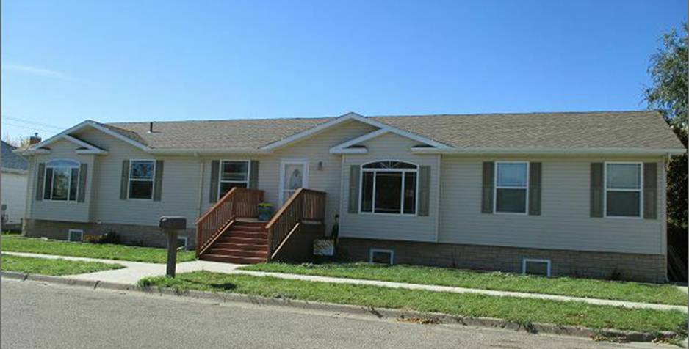
RECORD #5894

LOT SIZE 50’ X 145.7’ GROUND FLOOR 2288 SQ FT
SINGLE FAMILY ONE STORY BASEMENT 2288 SQ FT
AVERAGE QUALITY & CONDITION 1716 SQ FT FINISHED LIVING
BUILT IN 2008 MOD. HOME 4 BEDROOMS BELOW 1 FULL BATH
VINYL BRICK FACING 3 BEDROOMS ABOVE 2BATHS
4 EGRESS WINDOWS EAST SIDE
NATURAL GAS CENTRAL AIR 320 SQ FT WOOD DECK
SOLD ON 8/31/17 FOR $205,000
ASSESSED IN 2017 AT $105,760 RECORD #5894
ASSESSED IN 2012 $178,000
2009 12’ X 16’ TOOL SHED
HICKORY CABINETS
30’ X 40 DET. GARAGE WITH 10’ BRZWY

