$140,000.00
GROSZ-KNUTH
302 8TH ST WEST, MOBRIDGE
MOBRIDGE NWTS 1ST ADDN LOTS 7 & 8 BLOCK 11
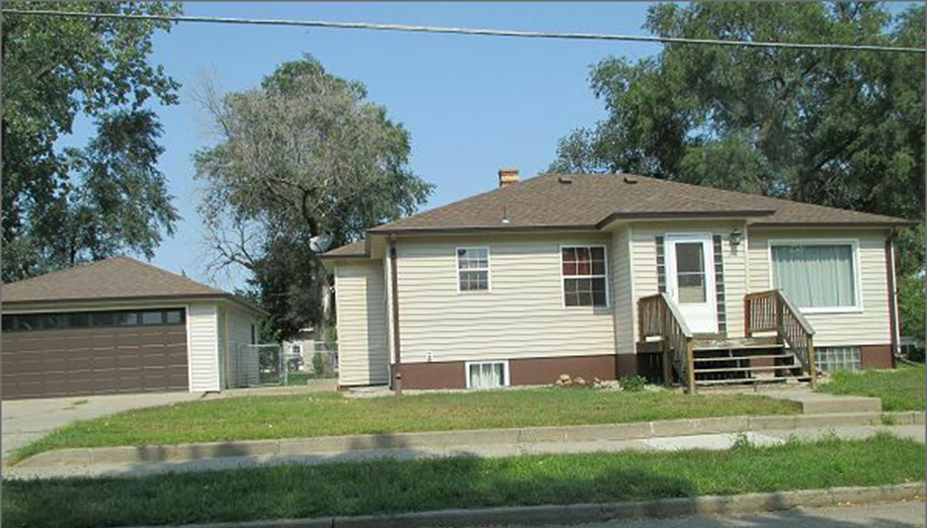
RECORD #5970

LOT SIZE 70’ X 140’ TOTAL LIVING AREA 1236 SQ FT
SINGLE FAMILY ONE STORY 3 BEDROOMS 1 ½ BATHS
AVERAGE QUALITY & CONDITION BASEMENT 1236 SQ FT
BUILT IN 1925 DETACHED GARAGE 640 SQ FT
CENTRAL AIR NATURAL GAS SOLID WALL PORCH 64 SQ FT
1998 12’ X 20’ GARAGE ADDITION
2008 NEW SIDING, WINDOWS, & DOORS
2014 MAJOR REMODEL, ROOF GOOD
FOUNDATION GOOD, VINYL SIDING
GARAGE-VINYL SIDING-ROOF GOOD RECORD #5970
SOLD ON 8/19/17 FOR $140,000
ASSESSED IN 2017 AT $116,850
ASSESSED IN 2012 AT $35,360 SOLD IN 2015 FOR $132,000

