$63,000.00
CROWSHAW-REINHOLZ
318 2ND AVE EAST, MOBRIDGE
MOBRIDGE MILW LAND CO’S 1ST ADDN LOT 11 BLOCK 18
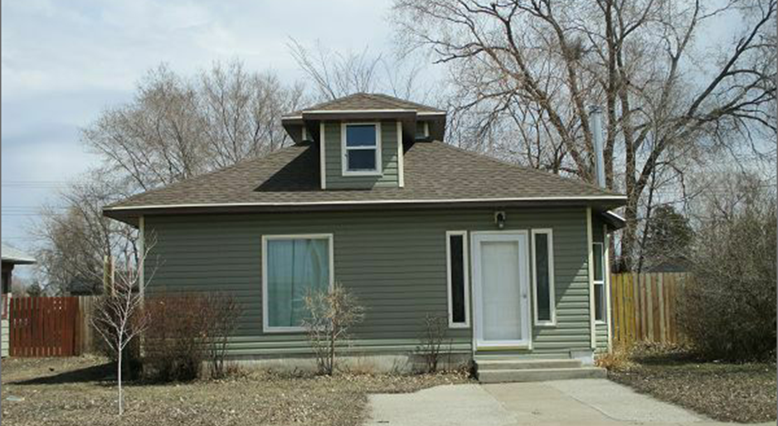
RECORD #5776

LOT SIZE 50’ X 140’ TOTAL LIVING AREA 804 SQ FT
ONE STORY-SINGLE FAMILY 2 BEDROOMS 1 BATH
AVERAGE QUALITY & CONDITION 9’ X 14’ SHED
BUILT IN 1920 SOLID WALL PORCH 132 SQ FT
2013; REDO KITCHEN,BATHROOM
LIVING ROOM,REPLACE WINDOWS
SOLD ON 11/9/17 FOR $63,000
ASSESSED IN 2017 AT $6,750
ASSESSED IN 2012 AT $6,510 RECORD #5776

