$27,500.00
FUHRER-HEPPER
314 2ND AVE EAST, MOBRIDGE
MOBRIDGE MILW LAND CO’S 1ST ADDN LOT 10 BLOCK 18
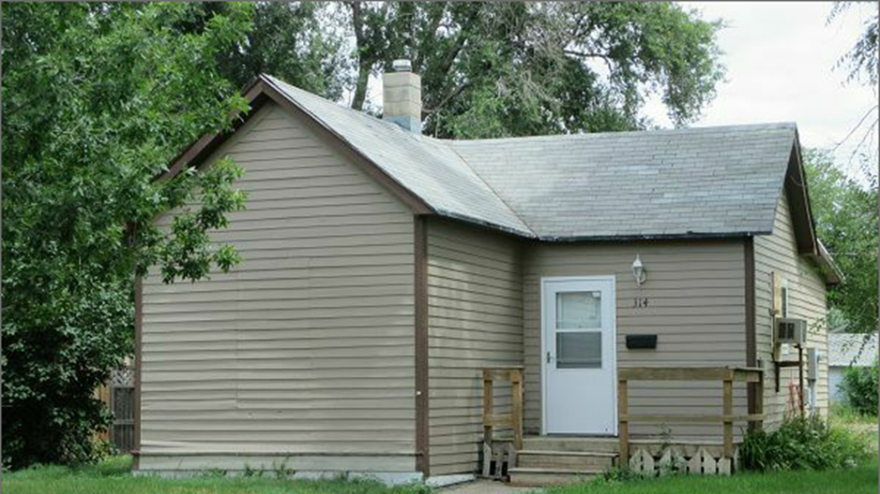
RECORD #5775

LOT SIZE 50’ X 140’ TOTAL LIVING AREA 672 SQ FT
SINGLE FAMILY ONE STORY 2 BEDROOMS
AVERAGE QUALITY AND CONDITION ¾ BATH 8 FIXTURES
BUILT IN 1940 WOOD DECK 66 SQ FT
2014; OLD CASEMENT WINDOWS BAD SOLID WALL PORCH 32 SQ FT
SIDING POOR, ROOF FAIR, NO GUTTERS
WINDOW AIR, FORCED AIR HEATED DETACHED GARAGE 288 SQ FT
SOLD ON 7/21/17 FOR $27,500
ASSESSED IN 2017 AT $12,260
SOLD IN 2016 FOR $19,000 RECORD # 5775
ASSESSED IN 2012 AT $11,080
SOLD 3 TIMES IN 2014 FOR $9,500, $12,000 & $20,000

