$35,000.00
MOON-KEMNITZ
1013 1ST AVE WEST, MOBRIDGE
MOBRIDGE MAIN PARK LOT 4 & N ½ OF LOT 5 BLOCK 23
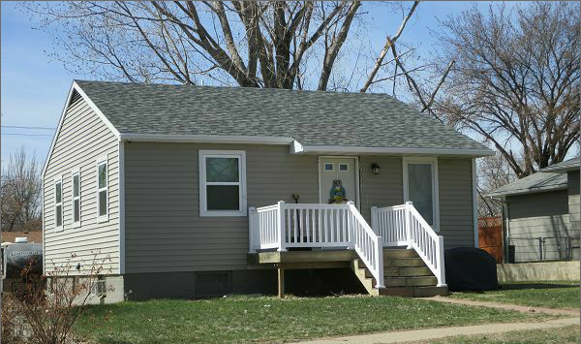
RECORD #5713

LOT SIZE 56.25’ X 142’ GROUND FLOOR 756 SQ FT
SINGLE FAMILY 2 BEDROOMS 1 ¾ BATH
ONE STORY BASEMENT 756 SQ FT
AVERAGE QUALITY AND CONDITION BASEMENT 700 SQ FT LIVING
BUILT IN 1940 DETACHED 480 SQ FT GARAGE
NATURAL GAS CENTRAL AIR SOLID WALL PORCH 70 SQ FT
2014 VINYL RESIDING, NEW WINDOWS,GOOD ROOF OPEN SLAB PORCH 336 FT
SOLD ON 11/18/16 FOR $35,000 BOOK 16 PAGE 842
ASSESSED IN 2017 AT $60,930
ASSESSED IN 2012 AT $28,355 RECORD #5713

