$175,000.00
UNTERSEHER-ABERLE
809 NORTH MAIN, MOBRIDGE
LOTS 4, 5, 6 & N1/2 OF LOT 7 BLOCK 20
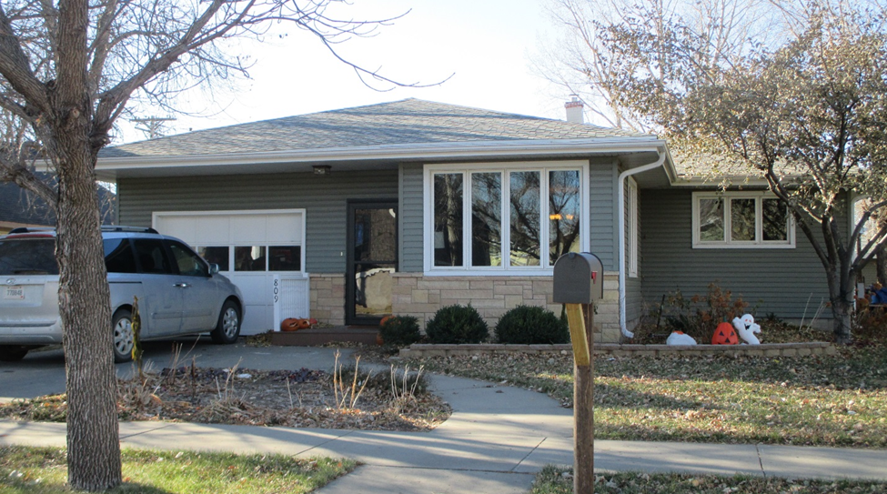
RECORD #’S 5684 & 5685

LOT SIZE 56.25 X 152 GROUND FLOOR 1742 SQ FT
ADJACENT LOTS 75’ X 152’ 3 BEDROOMS 1 ½ BATHS
ONE STORY SINGLE FAMILY FULL BSMT 1000 SQ FT REC.
AVERAGE QUALITY & CONDITION CENTRAL AIR
BUILT IN 1965 347 SQ FT COVERED DECK
2014; BRICK PLANTER NORTH YARD 13 X 25 ATTACHED GARAGE
STONE FACE FRONT, STEEL SIDING 26 X 28 DETACHED GARAGE
BLOCK BSMT, SLAB & HOT TUB
DETACHED GARAGE STEEL SIDING GOOD RECORD # 5684 & 5685
SOLD ON 7/25/17 FOR $175,000, SOLD IN 2011 FOR $159,000
ASSESSED IN 2017 AT $172,640, IN 2012 AT $75,710

