$41,500.00
BADER - M & C RENTAL PROPERTIES
822 NORTH MAIN, MOBRIDGE
MOBRIDGE MAIN PARK N ½ OF LOT 15 & ALL OF LOT 16 BLOCK 13
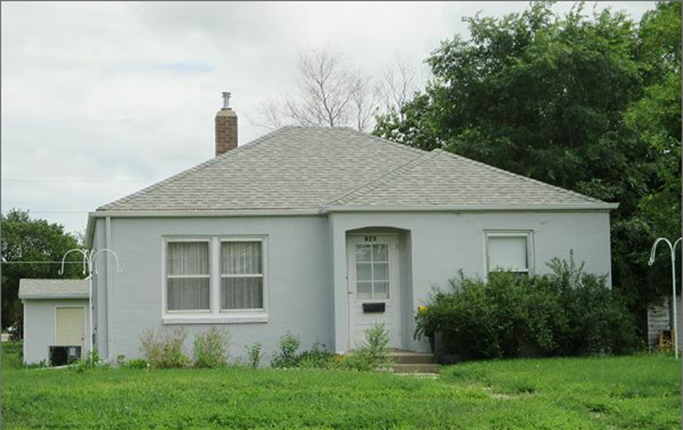
RECORD #5637

LOT SIZE 56.25’ X 152’ GROUND FLOOR 814 SQ FT
SINGLE FAMILY ONE STORY 2 BEDROOMS 1 ½ BATHS
BUILT IN 1947 BASEMENT 814 SQ FT
AVERAGE QUALITY AND CONDITION 203 SQ FT FINISHED LIVING
2014; STUCCO, ALUMINUM WINDOWS DETACHED GARAGE 308 SQ FT
SUNKEN WINDOW WELLS, NATURAL GAS CENTRAL AIR
GARAGE VERTICAL HARDBOARD
SOLD ON 6/12/17 FOR $41,500 BOOK 17 PAGE 410
ASSESSED IN 2017 AT $60,980
SOLD IN 2001 FOR $25,000
ASSESSED IN 2012 $31,205 RECORD #5637

