$187,500.00
FORBES-LASHMET/BRYANT
403 10TH ST EAST, MOBRIDGE
MOBRIDGE MAIN PARK N 10’ OF LOT 14 & ALL LOTS 15 & 16 BLOCK 3
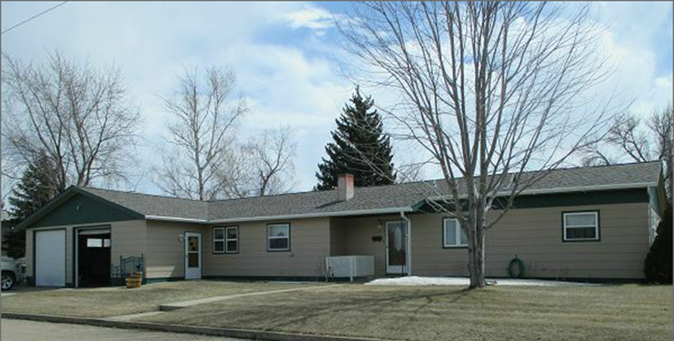
RECORD #5567

LOT SIZE 85’ X 142’ GROUND FLOOR 1906 SQ FT
SINGLE FAMILY-ONE STORY 3 BEDROOMS ABOVE
AVERAGE QUALITY & CONDITION 1 BEDROOM BASEMENT
BUILT IN 1965 2 FULL BATHS, ONE HALF BATH
2014; ROOF GOOD, WINDOWS GOOD BASEMENT 480 SQ FT
NATURAL GAS, LARGE EGRESS 350 SQ FT FINISHED LIVING
SOLD ON 2/9/18 FOR $187,500 GARAGE 960 SQ FT
ASSESSED IN 2017 AT $169,240 ROOFED PORCH 44 SQ FT
SOLD IN 2011 FOR $125,000 KNEE WALL PORCH 128 SQ FT
ASSESSED IN 2012 AT $91,800 OPEN SLAB PORCH 176 SQ FT
SOLD IN 2004 FOR $82,000

RECORD #5567

