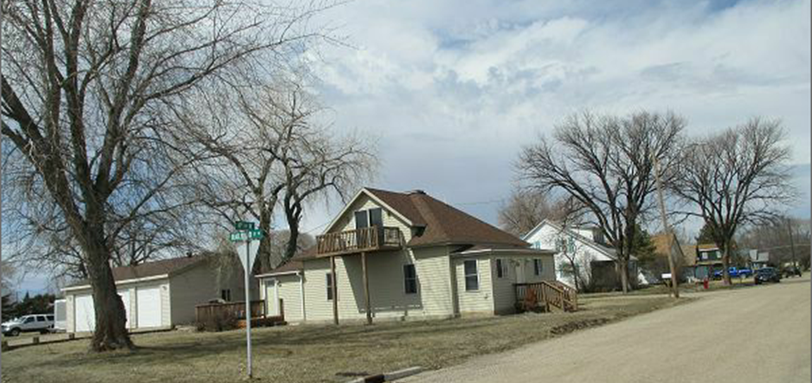
$120,000.00
SAYLER-WEBSTER
203 4TH AVE WEST, MOBRIDGE
MOBRIDGE GRAND CROSSING OUTLOTS OUTLOT A
RECORD #5526

LOT SIZE 67’ X 140’ TOTAL LIVING 1288 SQ FT
SINGLE FAMILY-ONE STORY MAIN FLOOR 1032 SQ FT
AVERAGE QUALITY & CONDITION BASEMENT 728 SQ FT
BUILT IN 1907 2 BEDROOMS 1 ½ BATHS
LOTS OF REMODELING 10’ X 16’ SOLID WALL PORCH
CENTRAL AIR, LOWER DECK POOR 6’ X 12’ WOOD DECK
SOLD ON 1/31/17 FOR $120,000 30’ X 40’ DETACHED GARAGE
ASSESSED IN 2017 AT $72,590
SOLD IN 2010 FOR $74,000
ASSESSED IN 2012 AT $56,635 RECORD #5526
SOLD IN 2009 FOR $68,500, 2006 FOR $55,000

