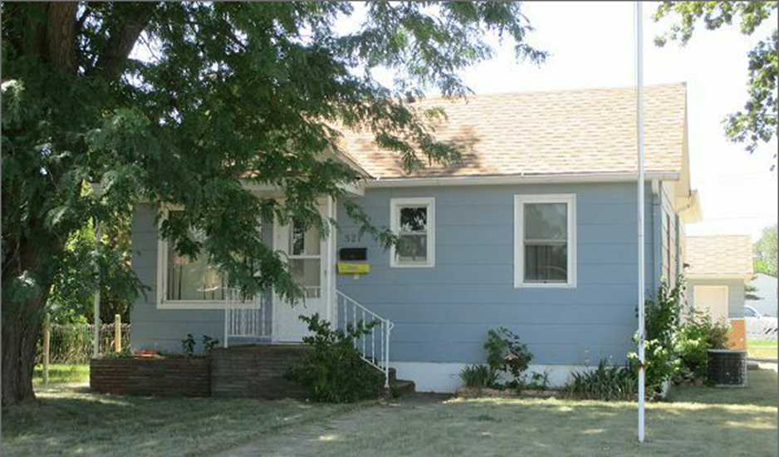
$48,000.00
MILLER-LANG
521 3RD AVE EAST, MOBRIDGE
MOBRIDGE GRAND CROSSING ADDITION N. 43’ LOT 11A BLOCK 61
RECORD #5492

LOT SIZE 43’ X 140’ GROUND FLOOR 814 SQ FT
SINGLE FAMILY ONE STORY 2 BEDROOM 1 ½ BATH
AVERAGE QUALITY AND CONDITION BASEMENT 814 SQ FT
BUILT IN 1920 414 SQ FT OF BASEMENT FIN.
CENTRAL AIR DETACHED GARAGE 336 SQ FT
2014; ROOF GOOD, MASONITE SIDING GOOD 4 X 14 ROOF OVER PORCH
ALUMINUM STORM SCREEN GOOD
BLOWN IN INSULATION
SOLD ON 6/16/17 FOR $48,000 RECORD #5492
ASSESSED IN 2017 AT $61,120
SOLD IN 2015 FOR $65,000
ASSESSED IN 2012 AT $30,135
SOLD IN 2009 FOR $45,000

