$157,000.00
LIND-LIPP
702 1ST AVE EAST, MOBRIDGE
MOBRIDGE GRAND CROSSING ADDN LOT 7 & S 15’ OF LOT 8 BLOCK 60
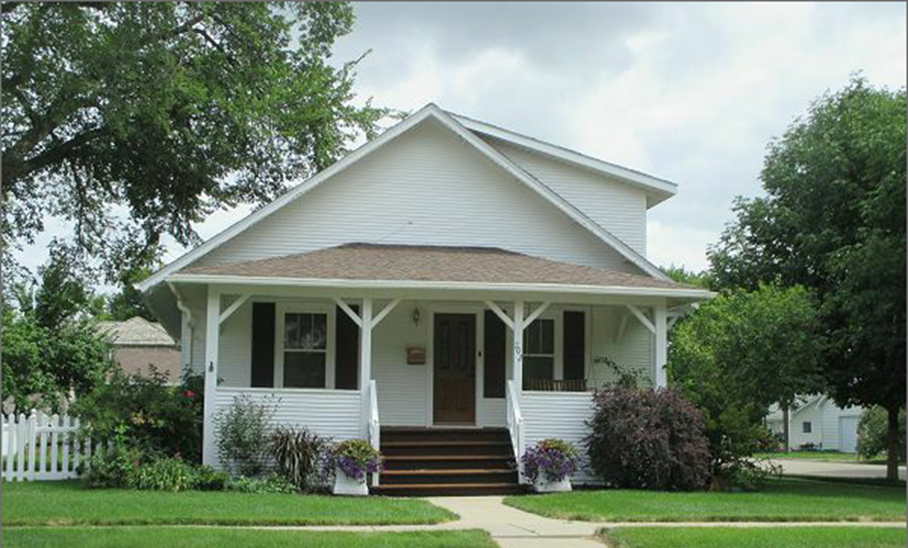
RECORD #5465

LOT SIZE 65’ X 140’ GROUND FLOOR 1102 SQ FT
SINGLE FAMILY 1 ½ STORY TOTAL LIVING AREA 1653 SQ FT
BUILT IN 1925 4 BEDROOMS 2 BATHS
AVERAGE QUALITY & CONDITION BASEMENT 1102 SQ FT
2014; COVERED FRONT PORCH DETACHED GARAGE 240 SQ FT
LAP SIDING FAIR, CASEMENT-TRIM FAIR ROOFED PORCH 200 SQ FT
3 SEASON PORCH, BRICK WALK & PATIO KNEE WALL PORCH 98 SQ FT
GARAGE VINYL SIDING, VINYL FENCE 2014; WALL REMOVED BETWEEN
CENTRAL AIR, ROOF FAIR, FOUNDATION FAIR KITCHEN AND DINING ROOM
SOLD ON 7/20/17 FOR $157,000 BOOK 17 PAGE 520
ASSESSED IN 2017 AT $82,270
ASSESSED IN 2012 AT $42,585 RECORD #5465

