$87,000.00
SPILOS – AARON
110 7TH ST EAST, MOBRIDGE
MOBRIDGE GRAND CROSSING ADDN LOTS 8B, 9 & 10 BLOCK 59
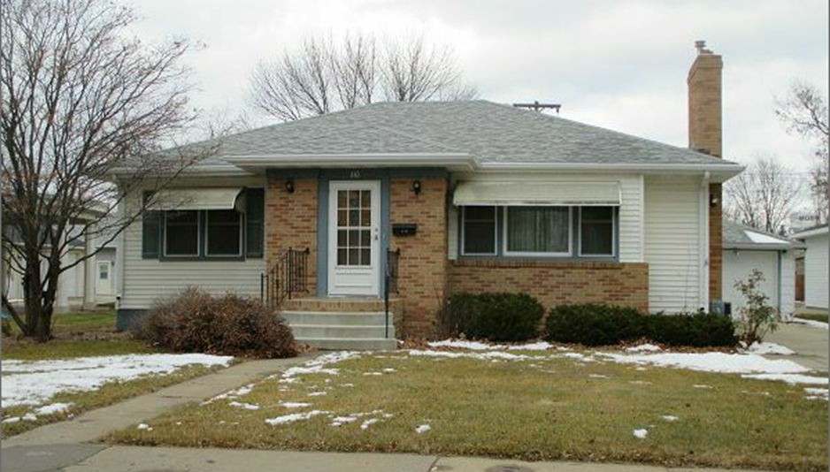
RECORD #5454
LOT SIZE 62.5’ X 140’ GROUND FLOOR 1164 SQ FT
SINGLE FAMILY ONE STORY FINISHED BSMT 1140 SQ FT
AVERAGE QUALITY & CONDITION 2 BEDROOMS ABOVE
BUILT IN 1949 1 BEDROOM BELOW
2014; ROOF GOOD, ALUM. SIDING 2 BATHS 8 FIXTURES
CENTRAL AIR NATURAL GAS DETACHED GARAGE 336 SQ FT
SOLD ON 11/3/17 FOR $87,000 2ND DETACHED GARAGE 336 SQ FT
ASSESSED IN 2017 AT $91,870 ROOFED PORCH 677 SQ FT
ASSESSED IN 2012 AT $58,020 OPEN SLAB PORCH 1060 SQ FT
RECORD #5454

