$120,000.00
STOICK – UNTERSEHER
701 1ST AVE EAST, MOBRIDGE
MOBRIDGE GRAND CROSSING ADDN LOTS 4 & 5 BLOCK 59
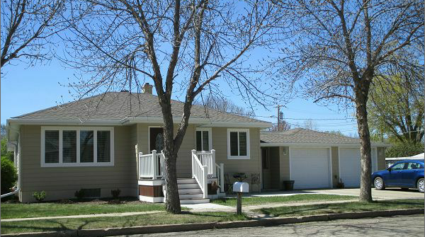
RECORD # 5452

LOT SIZE 55’ X 140’ 952 SQ FT 1ST FLOOR
SINGLE FAMILY 2 BEDROOMS 1 BATH
ONE STORY BASEMENT 952 SQ FT
AVERAGE QUALITY AND CONDITION 2 BEDROOMS ½ BATH
BUILT IN 1955 NATURAL GAS CENTRAL AIR
2014; METAL COVERED WOOD DECK ATTACHED GARAGE 528 SQ FT
SHINGLE ROOF GOOD WOOD SIDING FAIR DETACHED GAR. 10X20
BLOCK FDN GOOD EGRESS WINDOW SOUTH CARPORT
CHAIN LINK FENCE 8X8 DECK SPRINKLER SYSTEM
SOLD ON 4/19/17 FOR $120,000 SOLID WALL PORCH 67 SQ FT
ASSESSED IN 2016 AT $92,230
SOLD IN 2013 FOR $85,000 ASSESSED IN 2012 AT $50,525

