$77,500.00
MAUDE-SCHMIDT
611 6TH AVE WEST, MOBRIDGE
MOBRIDGE GRAND CROSSING ADDN LOT 4 BLOCK 51
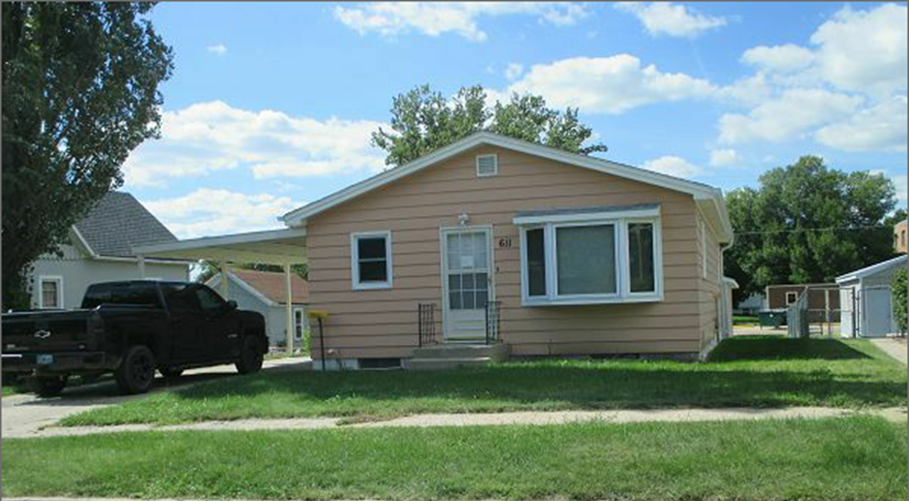
RECORD #5391

LOT SIZE 50’ X 140’ GROUND FLOOR AREA 960 SQ FT
SINGLE FAMILY ONE STORY 1 FULL BATH, ONE ¾ BATH
AVERAGE QUALITY & CONDITION ONE ½ BATH
BUILT IN 1960 1 BEDROOM ABOVE ONE BELOW
2005; NEW 24’ X 28’ GARAGE BASEMENT 960 SQ FT, 500 FIN REC
2006; NEW THERMO PANE WINDOWS DETACHED GARAGE 24’ X 28’
2012 ELECTRIC UPGRADE CARPORT 13’ X 22’
2014; SHINGLES POOR, CASEMENT WINDOWS GOOD
NATURAL GAS CENTRAL AIR 8’ X 10’ SHED
SOLD ON 8/21/17 FOR $77,500
ASSESSED IN 2017 AT $84,110
SOLD IN 2004 FOR $51,500 RECORD #5391
ASSESSED IN 2012 AT $45,740

