$20,000.00
HEPPER-GEORGE
609 4TH AVE WEST, MOBRIDGE
MOBRIDGE GRAND CROSSING ADDN LOT 4 BLOCK 49
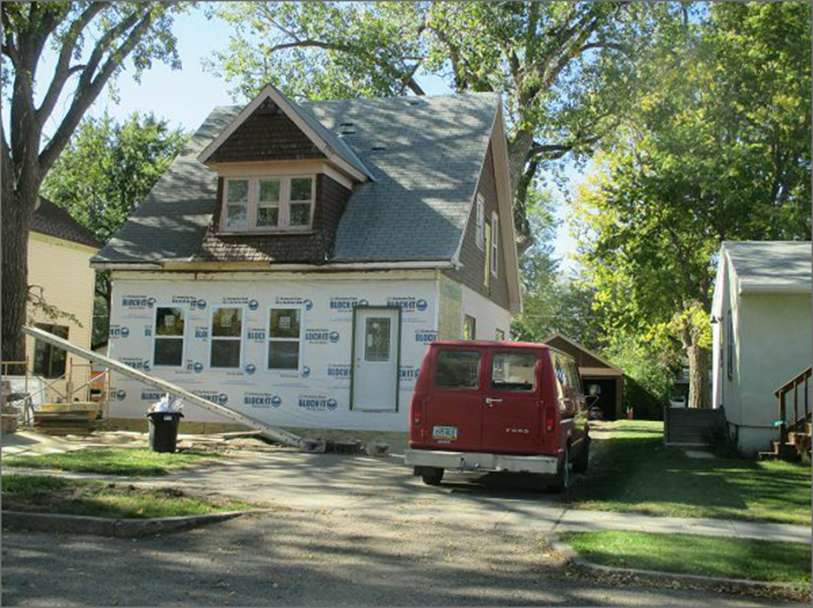
RECORD #5370

LOT SIZE 50’ X 140’ GROUND FLOOR AREA 756 SQ FT
SINGLE FAMILY 1 ½ STORY TOTAL LIVING AREA 1255 SQ FT
AVERAGE QUALITY & CONDITION 3 BEDROOMS 1 ¾ BATHS
BUILT IN 1925 BASEMENT 624 SQ FT
2014; SHINGLES POOR, TRIM BAD REC ROOM 156 SQ FT
GARAGE POOR, FOUNDATION GOOD SOLID WALL PORCH 192 SQ FT
2010; NEW NATURAL GAS FURNACE OPEN SLAB PORCH 252 SQ FT
SOLD ON 8/27/17 FOR $15,000 DETACHED GARAGE 480 SQ FT
SOLD ON 8/31/17 FOR $20,000
ASSESSED IN 2017 AT $31,105
ASSESSED IN 2012 AT $26,720 RECORD # 5370

