$40,000.00
FUHRER-WIPF
507 3RD AVE WEST
MOBRIDGE GRAND CROSSING ADDN LOT 5 BLOCK 38
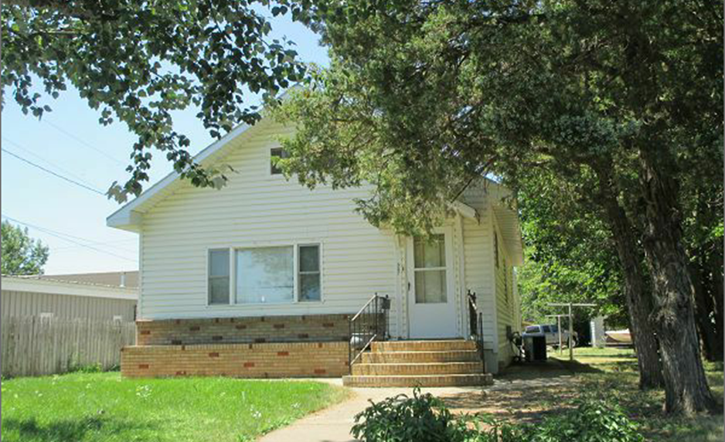
RECORD #5299

LOT SIZE 50’ X 140’ GROUND FLOOR 960 SQ FT
SINGLE FAMILY 2 BEDROOMS 1 ½ BATHS
ONE STORY BASEMENT 960 SQ FT
AVERAGE QUALITY AND CONDITION BASEMENT HALF FINISHED
BUILT IN 1940 + - ATTACHED GARAGE 576 SQ FT
CENTRAL AIR NATURAL GAS BRICK STEPS AND PLANTER
2014; VINYL SIDING FAIR, WINDOWS GOOD 1999 RESIDE 3 SIDES
BLOCK BASEMENT FAIR 1999 REPLACE WINDOW
1992 ELECTRICAL UPGRADE
SOLD ON 6/5/17 FOR $40,000 RECORD #5299
ASSESSED IN 2017 AT $52,000, IN 2012 AT $29,335

