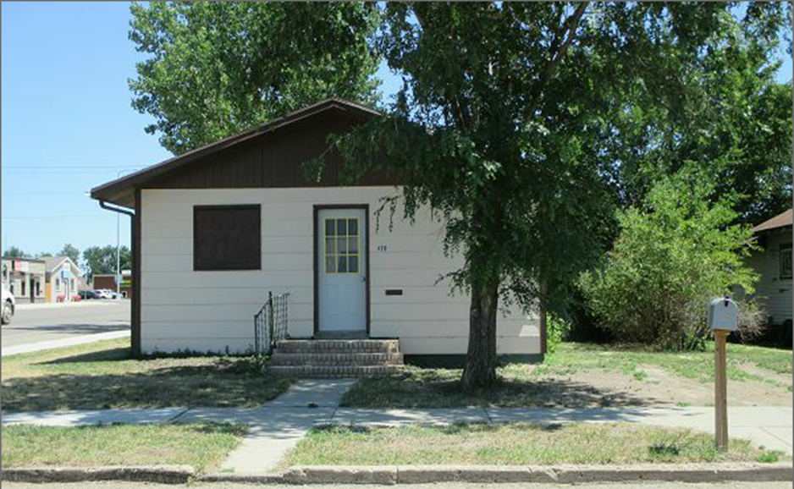
$6,000.00
ELLISON-HAEFNER
420 4TH AVE WEST, MOBRIDGE
MOBRIDGE GRAND CROSSING ADDN LOT 12 BLOCK 29
RECORD #5230

LOT SIZE 50’ X 140’ TOTAL LIVING AREA 1056 SQ FT
SINGLE FAMILY 3 BEDROOMS
SINGLE STORY BASEMENT 912 SQ FT
AVERAGE QUALITY AND CONDITION A BATH 5 FIXTURES
BUILT IN 1920 DETACHED GARAGE 216 SQ FT
HEATING FORCED AIR WINDOW AC
TIN ROOF ON MAIN PART OF HOUSE
SOLD ON 5/4/17 FOR $6,000 BOOK 17 PAGE 287
SOLD ON 11/9/15 FOR $7,500 BOOK 15 PAGE 891
SOLD IN 2009 FOR $1,000 BOOK 9 PAGE 4
ASSESSED IN 2017 AT $9,770 RECORD #5230
ASSESSED IN 2012 AT $21,590

