$16,900.00
TB PROPERTIES LLC-BAKER
605 5TH AVE EAST, MOBRIDGE
MOBRIDGE FAIRVIEW ADDN LOT 7 BLOCK 15
RECORD #5109
VERIFICATION LETTER SAYS BUYER PAID $21,900
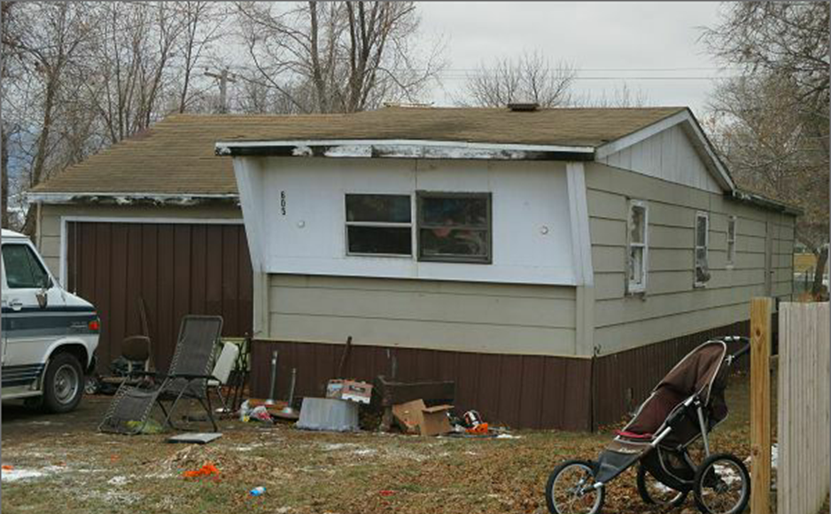
LOT SIZE 37.5’ X 140’ GROUND FLOOR 720 SQ FT
MANUFACTURED HOME 3 BEDROOMS 1 BATH
BUILT IN 1970 + - ATTACHED GARGE 336 SQ FT
FAIR QUALITY & CONDITION
SOLD ON 8/2/17 FOR $16,900
PREVIOUS ASSESSED VALUES DO NOT INCLUDE MH
ASSESSED IN 2017 AT $3,030 RECORD #5109
SOLD IN 2015 FOR $1,000
SOLD IN 2013 FOR $1,300 TAX DEED
ASSESSED IN 2012 T $1,179

