$65,000.00
WALZ- ROEBUCK, NISBET
30 7TH AVE EAST, MOBRIDGE
MOBRIDGE EKLO’S 3RD ADDN LOT 26A
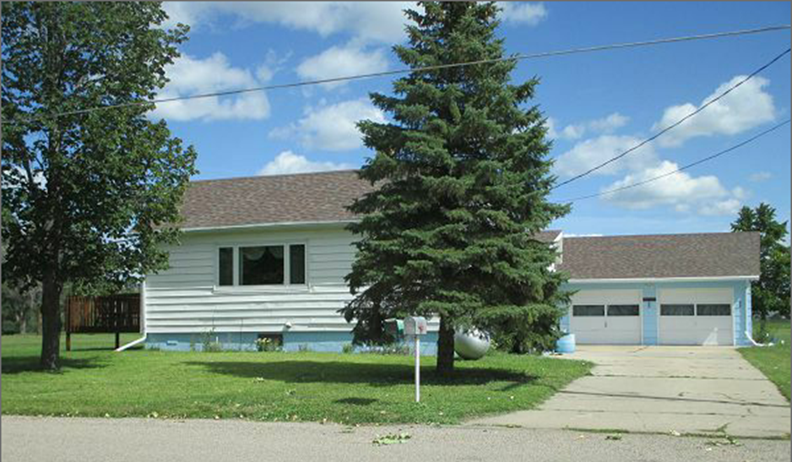
RECORD #5038

LOT SIZE 50’ X 139.8’ GROUND FLOOR AREA 780 SQ FT
SINGLE FAMILY ONE STORY 3 BEDROOMS 1 BATH
AVERAGE QUALITY & CONDITION 2 HALF BATHS
BUILT IN 1940 BASEMENT 780 SQ FT
2014: MASONITE GOOD, ROOF GOOD 200 SQ FT FIN. REC.
GARAGE ROOF GOOD, CENTRAL AIR 2 DOOR DETACHED GARAGE
SPRINKLER SYSTEM GARAGE 720 SQ FT
SOLD ON 8/8/17 FOR $65,000
ASSESSED IN 2017 AT $12,694
ASSESSED IN 2012 AT $14,695 RECORD #5038

