$62,360.00
JACKSON-RAU
203 7TH AVE SE, MOBRIDGE
MOBRIDGE EKLO’S 3RD ADDN LOT 17 EX THE N 40’ & ALL OF LOT 18
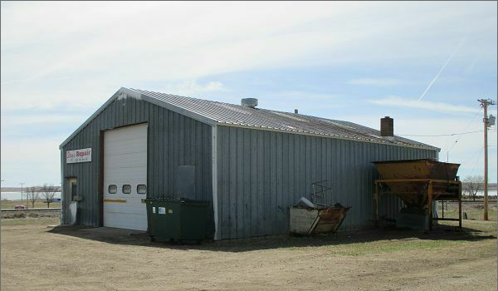
RECORD #5026

LOT SIZE 1.55 ACRES
100% EQUIPMENT SHED
1 STORY
BUILT IN 1970
ONE STORY RECORD #5026
SPACE HEATER
BADLY WORN
BUILDING 1728 SQ FT
SOLD ON 2/6/17 FOR $62,360
ASSESSED IN 2016 AT $14,105
SOLD IN 2008 FOR $31,000
ASSESSED IN 2012 AT $11,500

