$146,000.00
ULMER-PEPIN
1019 5TH AVE EAST, MOBRIDGE
MOBRIDGE BROWN’S 1ST ADDN NW4SW4 SEC 20-124-79 LOT 1 & N 60’ OF LOT 2 BLOCK 1
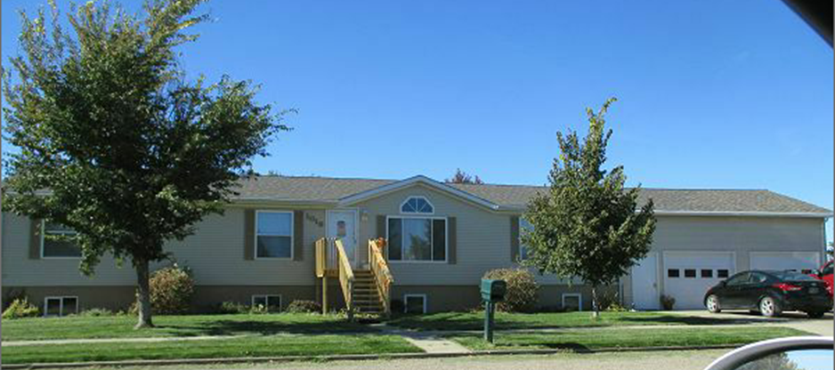
RECORD #4760

LOT SIZE 119’ X 150’ TOTAL LIVING AREA 1848 SQ FT
SINGLE FAMILY ONE STORY BASEMENT 1848 SQ FT
AVERAGE CONDITION & QUALITY 4 BEDROOMS
1999 NEW MH ON BASEMENT $75,000 2 BATHS
2006; SPRINKLER SYSTEM, NEW ROOF
2014; 4EGRESS EAST, 3 EGRESS WEST RECORD # 4760
SHINGLE GOOD, VINYL SIDING, CENTRAL AIR
20’ X 22’ SLAB PATIO, SLIDING GLASS DOOR
ALUMINUM/METAL WINDOWS GOOD
ATTACHED GARAGE 728 SQ FT
SOLD ON 8/25/17 FOR $146,000 BK 17 PG 608
ASSESSED IN 2017 AT $137,990
SOLD IN 2014 FOR $135,000 BK 14 PG 897
ASSESSED IN 2012 AT 487,655

