$124,500.00
SATHER-DOCKTER
611 CRESCENT DRIVE, MOBRIDGE
MOBRIDGE BEL-AIRE 2ND ADDN 2ND SUB LOT 11 BLOCK 2
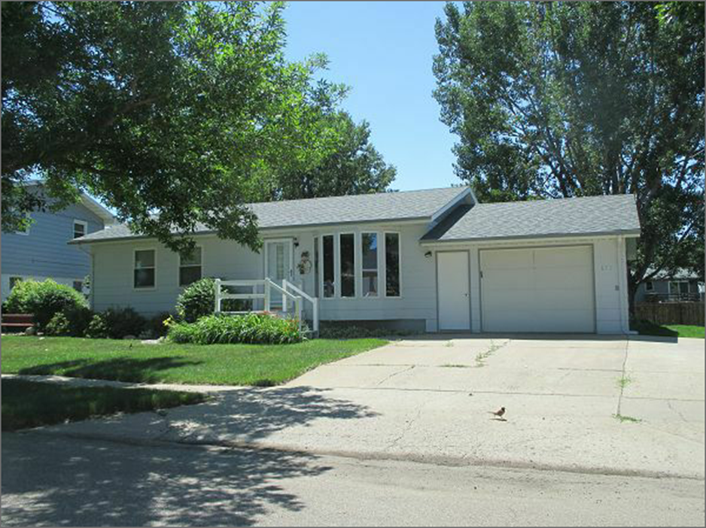
RECORD #4739

LOT SIZE 70’ X 125’ TOTAL LIVING AREA 1006 SQ FT
SINGLE FAMILY ONE STORY 3 BEDROOMS 1 BATH ABOVE
AVERAGE QUALITY AND CONDITION BASEMENT 850 SQ FT
BUILT IN 1972 1 BEDROOM 1 BATH BELOW
CENTRAL AIR NATURAL GAS ATTACHED GARAGE 416 SQ FT
2014; ROOF SHINGLES GOOD WOOD DECK 192 SQ FT
MASONITE SIDING, SLAB PATIO, DECK IN REAR PATIO SLAB 168 SQ FT
SOLD ON 6/15/17 FOR $124,500 SPRINKLER SYSTEM
ASSESSED IN 2017 AT $113,480 NO ALLEY ACCESS
ASSESSED IN 2012 AT $68,675 RECORD #4739

