$75,000.00
WHERRY-BONEN
3707 1ST AVE, SELBY
SELBY OVERHOLSERS ADDN N ½ LOT 9 & ALL LOT 10 BLOCK 3
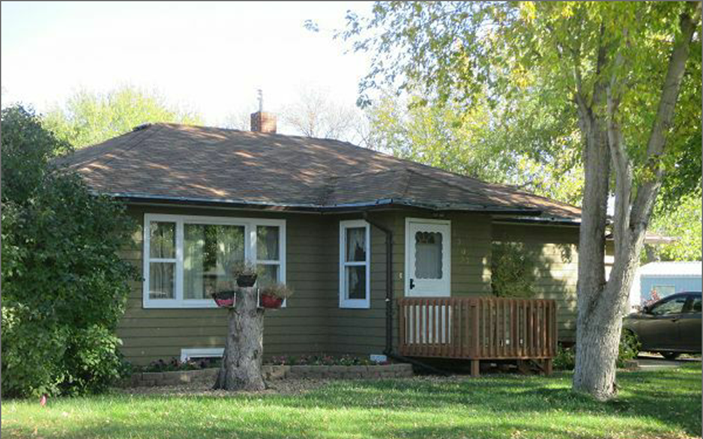
RECORD #4558

LOT SIZE 75’ X 140’ GROUND FLOOR 1040 SQ FT
SINGLE FAMILY, ONE STORY 2 BEDROOMS 1 ½ BATHS
BUILT IN 1955 BASEMENT 1040 SQ FT
AVERAGE QUALITY & CONDITION 520 SQ FT FINISHED REC
2015; ROOF GOOD, MASONITE SIDING I BEDROOM BELOW
CENTRAL AIR NATURAL GAS ATTACHED GARAGE 286 SQ FT
EGRESS WINDOW WEST SIDE SOLID WALL PORCH 48 SQ FT
SOLD ON 8/21/17 FOR $75,000 WOOD DECK 48 SQ FT
ASSESSED IN 2017 AT $70,880 1 BATH IN BASEMENT
SOLD IN 2007 FOR $53,000
ASSESSED IN 2012 AT $32,150 RECORD #4558

