$60,000.00
PFEIFLE-LEAVITT
3804 LINCOLN AVE. SELBY
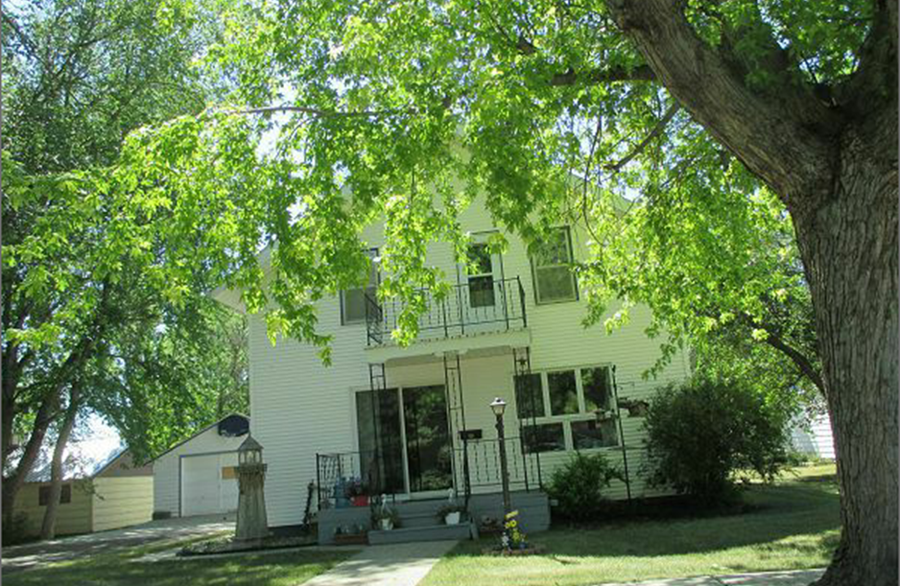
SELBY OVERHOLSERS ADDN S 30’ LOT 3 ALL OF LOT 4 AND N2 OF LOT 5 BLOCK 3
RECORD # 4554

LOT SIZE 105’ X 140’ TOTAL LIVING 1664 SQ FT
SINGLE FAMILY 2 STORY GROUND FLOOR 832 SQ FT
FAIR QUALITY AND CONDITION 4 BEDROOMS 2 BATHS
BUILT IN 1927 BASEMENT 832 SQ FT
NATURAL GAS CENTRAL AIR DETACHED GARAGE 520 SQ FT
2015; VINYL WINDOWS GOOD DETACHED GARAGE 384 SQ FT
1957 MOVED IN TO TOWN ROOFED PORCH 12’ X 5’
SOLD ON 6/22/17 FOR $60,000 WOOD DECK REAR
ASSESSED IN 2017 AT $66,750 RECORD #4554
ASSESSED IN 2012 AT $20,965 SOLD IN 2009 FOR $65,000 CFD

