$12,000.00
MAYER-THORSTENSON
2210 5TH AVE, SELBY
SELBY MILW LAND CO’S 2ND ADDN LOT 1 & N 37.5 OF LOT 2 BLOCK 29
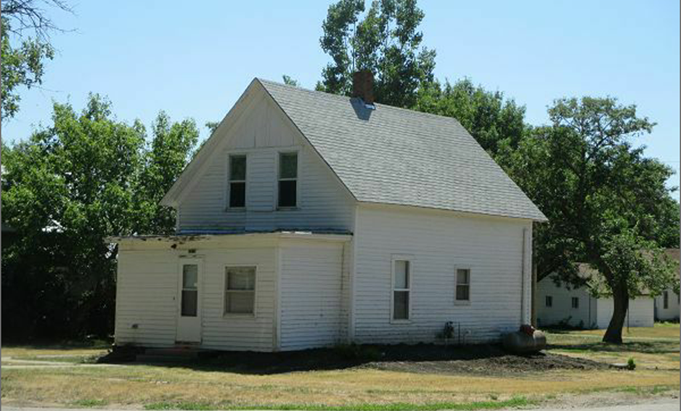
RECORD #4372

LOT SIZE 87.5’ X 140’ GROUND FLOOR 560 SQ FT
SINGLE FAMILY 1 ½ STORY TOTAL LIVING 840 SQ FT
FAIR QUALITY POOR CONDITION 2 BEDROOMS 1 BATH
NATURAL GAS 2001 2 SHEDS MOVED IN
2015; ROOF POOR, WOOD LAP SIDING POOR 6’X8’ SOLID WALL PORCH
FOUNDATION BULGING ON WEST 7’X18’ KNEE WALL PORCH
2011; 8’X12’ DECK, SOME WINDOWS REPLACED
SOLD ON 6/19/17 FOR $12,000 BUILT IN 1900 + -
ASSESSED IN 2017 AT $10,200
SOLD IN 2009 FOR $7,500
ASSESSED IN 2012 AT $7,029 RECORD #4372

