**$52,000.00**

**WARNER-WAHL**

**2201 MITCHELL ST. JAVA**

**JAVA 1ST ADDN TO PAYNE’S PLAT LOTS 1 & 2 BLOCK 5**

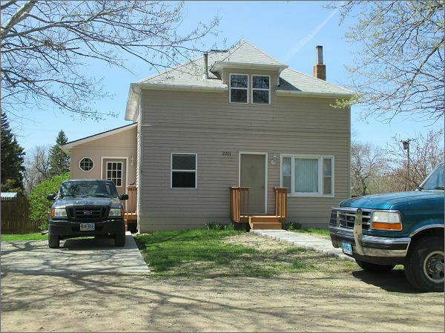**RECORD #4155**

**LOT SIZE 100’ X 140’ GROUND FLOOR AREA 936 SQ FT**

**SINGLE FAMILY TOTAL AREA 1404 SQ FT**

**1 ½ STORIES 4 BEDROOMS**

**AVERAGE QUALITY & CONDITION 6 FIXTURES**

**BUILT IN 1940 DIRT FLOOR CELLAR**

**2007 10’ X 14’ DECK $1,300 DETACHED GARAGE**

**CONCRETE SIDEWALK 13’ X 24’**

**CONCRETE DRIVEWAY 6’ X 8’ TREATED**

**SOLD ON 4/10/17 FOR $52,000**

**ASSESSED IN 2016 AT $7,075 RECORD #4155**

**ASSESSED IN 2012 AT $6,075**