THIS SALE AND SALE #4152 ARE ONE COMBINED SALE.

$50,000.00
FERGUSEN-FRONING
JAVA 1ST ADDN TO PAYNE’S PLAT LOTS 5 & 6 BLOCK 3
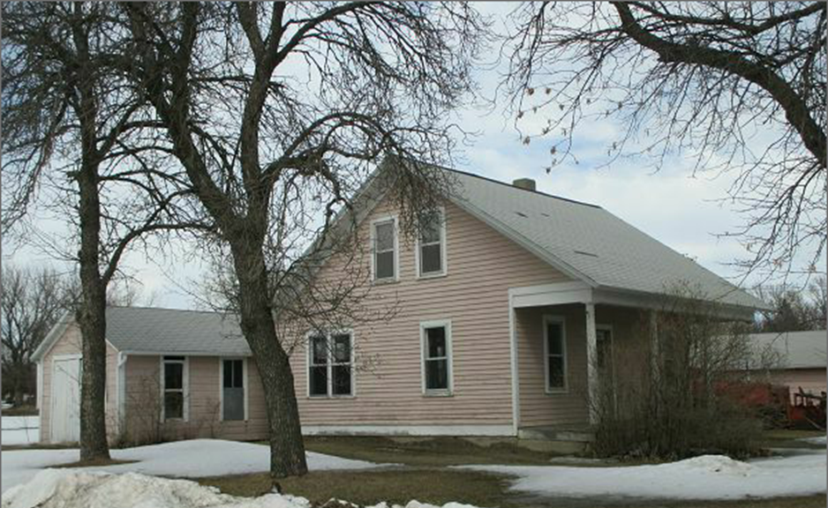
RECORD #4151

LOT SIZE 100’ X 140’ GROUND FLOOR 936 SQ FT
1 ½ STORY SINGLE FAMILY TOTAL AREA 1404 SQ FT
AVERAGE QUALITY & CONDITION 3 BEDROOMS 1 BATH
BUILT IN 1910 + - DETACHED GARAGE 1200 SQ FT
2014; REFURBISHED KITCHEN
NEW PRESSON TILE ON KITCHEN FLOOR
SOLD WITH SALE #4151 ON 2/2/18 FOR $50,000
ASSESSED IN 2017 FOR $20,680
ASSESSED IN 2012 AT $20,680 RECORD #4151

