$28,500.00
JENSEN-QUENOMEN
2112 1ST AVE WEST, JAVA
JAVA PAYNE’S PLAT E ½ OF LOTS 1 & 2 BLOCK 2
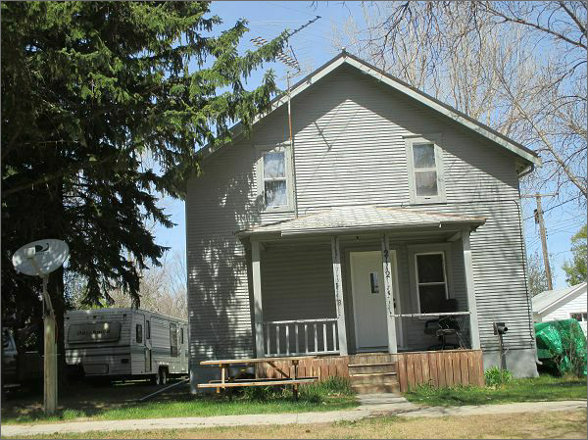
RECORD #4141

LOT SIZE 70’ X 100’ GROUND FLOOR AREA 720 SQ FT
SINGLE FAMILY TOTAL AREA 1080 SQ FT
2 STORY WORN CONDITION & QUALITY 3 BEDROOMS
BUILT 1900+ - MOVED ONTO LOT 1912 1 BATH
FLOOR FURNACE, ASPHALT SHINGLES ROOFED PORCH 72 SQ FT
SOLD ON 4/11/17 FOR $28,500 SOLID WALL PORCH 84 SQ FT
ASSESSED IN 2016 AT $10,485 DETACHED GARAGE 336 SQ FT
SOLD IN 2011 FOR $12,000 UNFINISHED BASEMENT 720 SQ FT
ASSESSED IN 2012 AT 8,790 RECORD #4141

