$335,000
BADGLEY-KONOLD
28737 127TH ST, MOBRIDGE
STR 21-124-79
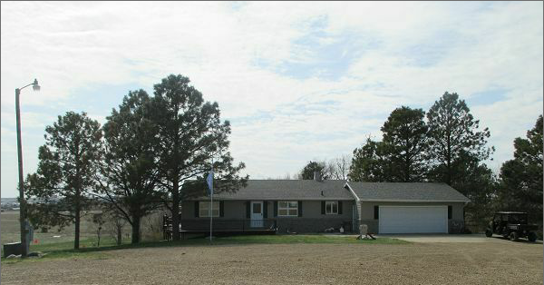
RECORD #3632

29.4 ACRES GROUND FLOOR 1288 SQ FT
ONE STORY 2 BEDROOMS 1 BATH
SINGLE FAMILY FINISHED WALKOUT BSMT 1288 SQ FT
AVERAGE QUALITY AND CONDITION 2 BEDROOMS 1 BATH
BUILT IN 1972 460 SQ FT OPEN SLAB PORCH
2015 ROOF GOOD, WOOD DECK 260 SQ FT WOOD DECK
SOUTH WRAPS AROUND TO WEST ATTACHED GARAGE 624 SQ FT
CENTRAL AIR WALKOUT BASEMENT WEST 32’ X 48’ POLE BLDG SHOP
3 SEASON AREA WEST 32’ X 48’ POLE BLDG BARN
SOLD ON 3/8/17 FOR $335,000 BOOK 17 PAGE 157
ASSESSED IN 2016 AT $316,295
ASSESSED IN $132,155 RECORD # 3632

