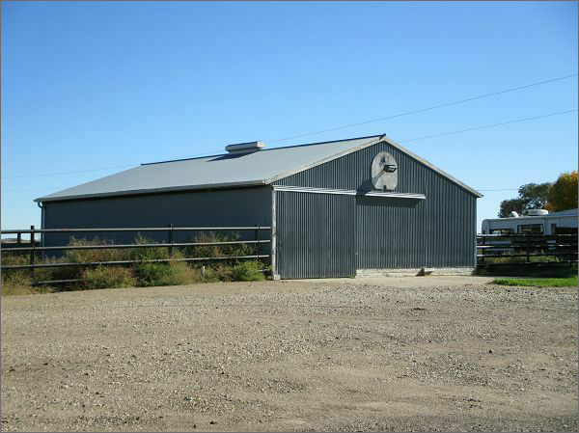
$260,000.00
TISDALL-SCHELL
2910 10TH AVE WEST, MOBRIDGE
RECORD #3486

