$260,000.00
TISDALL-SCHELL
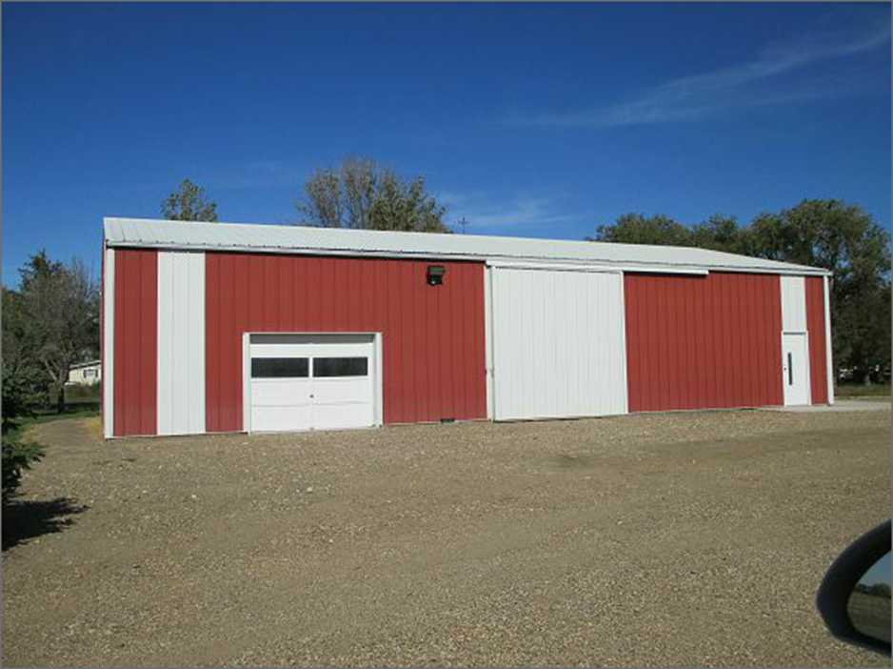
2910 10TH AVE WEST, MOBRIDGE
RECORD #3486

