$380,000.00
HAGGE-OSTER
28730 127TH ST, MOBRIDGE
LOT 1 EXC LOT 2 AIRPORT 2ND SUBD IN SE4SW4
16-124-79 ACQUIRED FOR AIRPORT PURPOSES; LOTS 1A 2 & 3
TRACT 1 SE4SW4 16-124-79
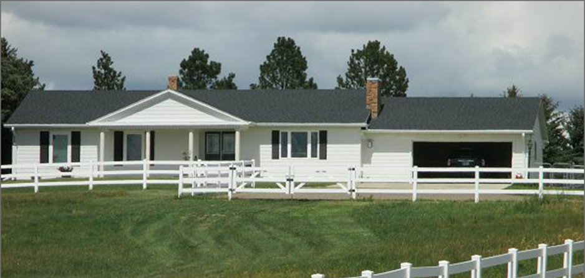
RECORD #3458

LOT SIZE 21.41 ACRES TOTAL LIVING AREA 1644 SQ FT
SINGLE FAMILY ONE STORY FINISHED BASEMENT 1644 SQ FT
AVERAGE QUALITY AND CONDITION 3 BEDROOMS 2 BATHS
2015;FIREPLACE, ROOF GOOD, EGRESS NORTH ROOFED PORCH 156 SQ FT
2 EGRESS WEST,DETACHED GARAGE OPEN SLAB PORCH 392 SQ FT
ROOF GOOD, VINYL SIDING ATTACHED GARAGE 670 SQ FT
BUILT IN 1973, CENTRAL AIR DETACHED GARAGE 1,216 SQ FT
SOLD ON 7/31/17 FOR $380,000 GAZEBO
ASSESSED IN 2017 AT $258,354 RECORD #3458
SOLD IN 2015 FOR $305,000
ASSESSED IN 2015 AT $134,015, IN 2012 AT $116,535
SOLD IN 2010 FOR $201,200

