$170,000.00
BUCKLIN-STIEGELMEIER
13071 US HWY 83, SELBY
NE4SE4 LESS AND EXCEPT FOR LOT H-4 IN THE SE4 IN 5-123-76
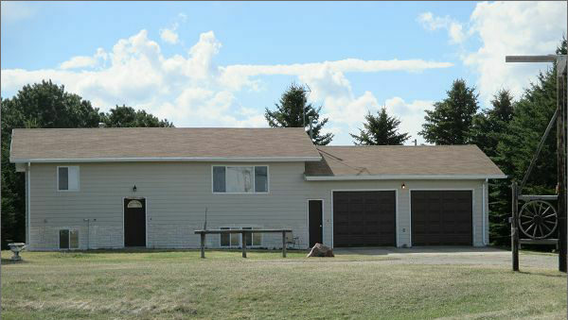
RECORD #1938

38.71 ACRES GROUND FLOOR 1040 SQ FT
SINGLE FAMILY BASEMENT 1040 SQ FT
ONE STORY 4 BEDROOMS 2 BATHS
AVERAGE QUALITY AND CONDITION 8 FIXTURES
BUILT IN 1980 BASEMENT 900 SQ FT FINISHED
WARMED AND COOLED ATTACHED 2 STALL GARAGE 676 SQ FT
SOLD ON 7/19/16 FOR $170,000 BOOK 16 PAGE 526
ASSESSED IN 2017 AT $176,944 WOOD DECK 64 SQ FT
ASSESSED IN 2012 AT $119,398 RECORD #1938

