$109,000.00
SK LESMEISTER INC – MW TIRED LLC
314 MAIN ST. MOBRIDGE
MOBRIDGE ORIGINAL LOTS 13, 14 & S 1’ OF LOT 15 (AKA LOT 15A) BLOCK 2
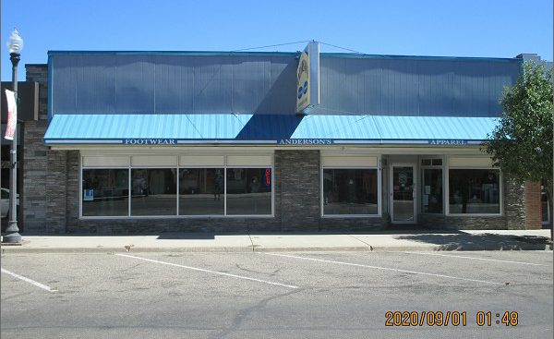
RECORD #6241

LOT SIZE 50’ X 140’ 6,900 SQ FT
100 % RETAIL STORE PARTIAL CRAWL SPACE
ONE STORY PACKAGE UNIT
AVERAGE QUALITY & CONDITION STEAM HEAT
BUILT IN 1957 2007 NEW CLOTH AWNING
SOLD ON 7/30/2020 FOR $109,000 1986 REMODEL $3,000
ASSESSED IN 2019 AT $112,445 2000 REMODEL $2,500
SOLD IN 2010 FOR $175,000
ASSESED IN 2012 AT $82,115 RECORD #6241

