$130,000.00
STROEHL – SCHMIDT
821 3rd AVE WEST, MOBRIDGE
MOBRIDGE NWTS 1ST ADDN LOT 1 & N 20’ OF LOT 2 BLOCK 12
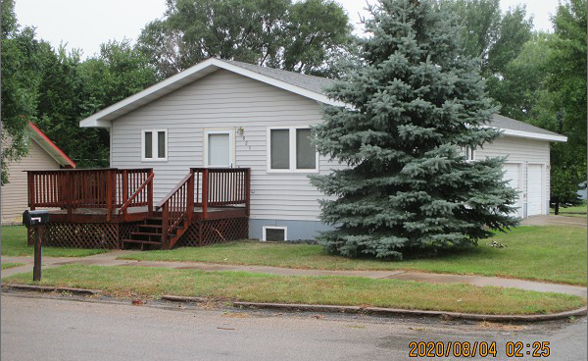
RECORD #5976

LOT SIZE 50’ X 140’ GROUND FLOOR 858 SQ FT
SINGLE FAMILY – 1 STORY 2 BEDROOMS 1 ½ BATHS
AVERAGE QUALITY & CONDITION BASEMENT 858 SQ FT
BUILT IN 1997 BSMT 600 SQ FT FIN REC
CENTRAL AIR - NATURAL GAS ATTACHED GARAGE 702 SQ FT
2009; INTERIOR REMODEL $7000 WOOD DECK 165 SQ FT
2010; NEW DECK 11’ X 15’ $1,200 SPRINKLER SYSTEM
BATHROOM IN BASEMENT $5,000
2015; EGRESS EAST, VINYL SIDING, WINDOWS GOOD
SOLD ON 7/10/2020 FOR $130,000
ASSESSED IN 2020 AT $116,240
SOLD 11/14/2016 FOR $116,000
ASSESSED IN 2016 AT $114,890 RECORD #5976

